Online Instruction Guidebook
PSY 100, Spring 2020
Version 3.23.20

This is a working manual and will be updated as needed

For Questions or Updates:
Ryan Rahm-Knigge
ryan.rahm-knigge@colostate.edu

Contents:

Hybrid Online Lecturing 2
Recording and Sharing Asynchronous Lectures 3
Recommendations 3
Step-by-Step Guide: Recording in PowerPoint 4
Step-by-Step Guide: Uploading Videos to OneDrive and Sharing with Students 8
Posting Links on Canvas 12
Livestreaming Lectures 14
Recommendations 14
Step-by-Step Guide: Livestreaming Lectures and Running Meetings on Microsoft Teams 15
Lectures on MS Teams and Responding to Students 18
Office Hours 22
Exams 23
General Recommendations 23
Step-by-Step Guide: Writing Multiple Choice Exams on Canvas 23
Assigning Exams and Creating Extended Times for Students with Accommodations 28
Research Participation 29
Extra Credit iClicker Quizzes on Canvas 30
The General Idea 30
Step-by-Step Guide: Extra Credit iClicker Quizzes on Canvas 31
Other Assignments (Mini Writings, Writing Assignments, etc) 36
Due Dates, Announcements, and Teaching Teams 37

Hybrid Online Lecturing

We will create a hybrid approach to online lecturing for PSY 100. Broadly, this will include providing access to lecture videos that students can watch at any time AND livestreaming the videos during lecture time so the instructor and students can interact. We will adjust this plan as-needed to ensure content is accessible to all students and meets accommodations needs.

This guidebook provides step-by-step instructions for how we will work to achieve this.

First, here is the broad picture of what we are doing:


1. Videos of the instructor lecturing are provided to students by or before the time of the regularly scheduled lecture. Students can watch these videos anytime. We will keep these lectures posted through the semester. Videos are published in around 10 minute chunks to reduce issues for students related to data/file size.


2. Pre-recorded lecture videos are livestreamed to students during scheduled lecture time. Instructors are encouraged to interact with students by answering questions, explaining concepts, showing demonstrations, etc.

Students are encouraged to attend the livestream session, but not required (life issues, tech issues, etc).

Livestream sessions are recorded with captions.



3. Recorded livestream sessions are posted for students to access anytime. Students who could not attend the livestream will benefit from observing the interactions and additional explanations from instructors. Videos will be available to students the entire semester.

Recording and Sharing Asynchronous Lectures

Recommendations

- Record lectures in PowerPoint.
  - Keep slides visually clean/minimal to help students who are watching on small devices
  - Do one long recording of the entire lecture.

- Lecture recordings should be in concept-sized or 10-minute chunks.
  - If you teach 50 minutes, aim for ≈ 5 videos; if 75 minutes, aim for ≈ 7-8 videos
  - This helps students with limited internet to access the videos
  - Save the one long recording you did in PowerPoint. Then, create separate PowerPoint files with just the slides for each 10-minute chunk.

- Continue to include videos, activities, Mini Writings, and iClicker questions when possible.
  - Pause and prompt for students to respond to iClicker questions or complete other activities

- Export PowerPoint recordings as .MP4 videos so students can watch them on mobile devices.
  - Video exports should be low quality .MP4 files to save space

- Store videos on OneDrive. Do not store videos on Canvas.
  - Have backups saved on your computer in case cloud systems crash.
  - Post OneDrive links on Canvas so students can find them.
  - Keep Canvas and OneDrive organized so students know exactly where to go
    - I recommend a Canvas Module per chapter/module, lecture day, or week to keep things easy for students to find
    - Label each video in sequence.
      - For example, if you’re teaching on Operant Conditioning and have 5, 10-minute videos, label them: Module 20 Operant Conditioning 1; Module 20 Operant Conditioning 2…

- Keep videos available all semester.

Step-by-Step Guide: Recording in PowerPoint

Assuming you’ve already created a typical, in-person lecture in PowerPoint, follow these steps to record yourself lecturing. Save your PowerPoint lecture as a new file so that you have a version with, and one without, the audio recordings (I’m guessing you won’t want audio recordings when we go back to in-person lectures).

1: To start recording, click “Slide Show” and then “Record Slide Show”
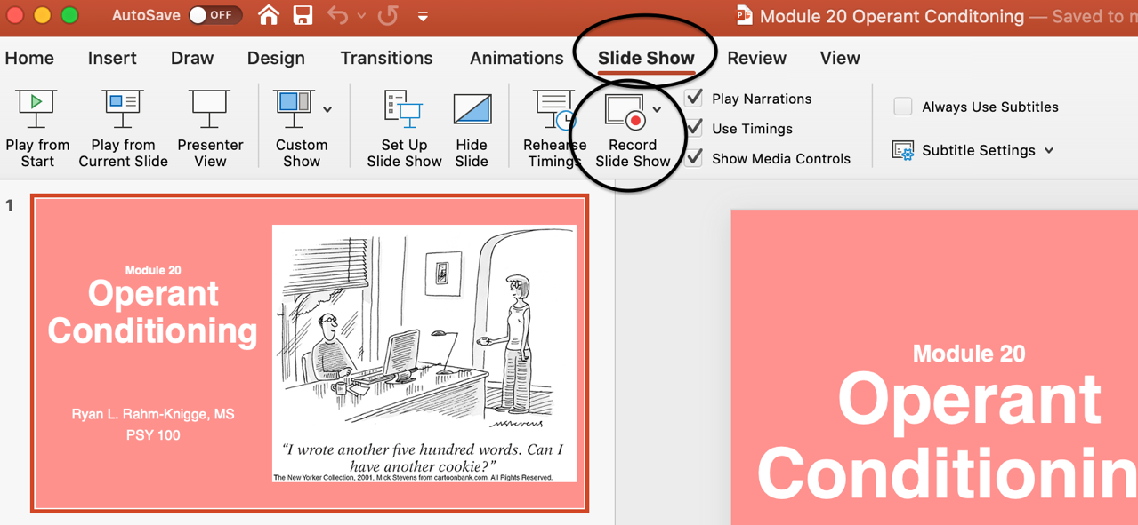

2: Your screen will look like this, which is pretty similar to Presenter View. You can advance your slides, skip slides, see your notes, play embedded videos, etc. The video will export as full-screen view, not Presenter View. Record sections (up to about 10 minutes). The recording will include what your mic picks up and the slides (with embedded content) - nothing else. If you link to videos that open in your browser, the videos won’t show up. I recommend embedding your videos so that they’ll play on the slide and be captured in the recording.
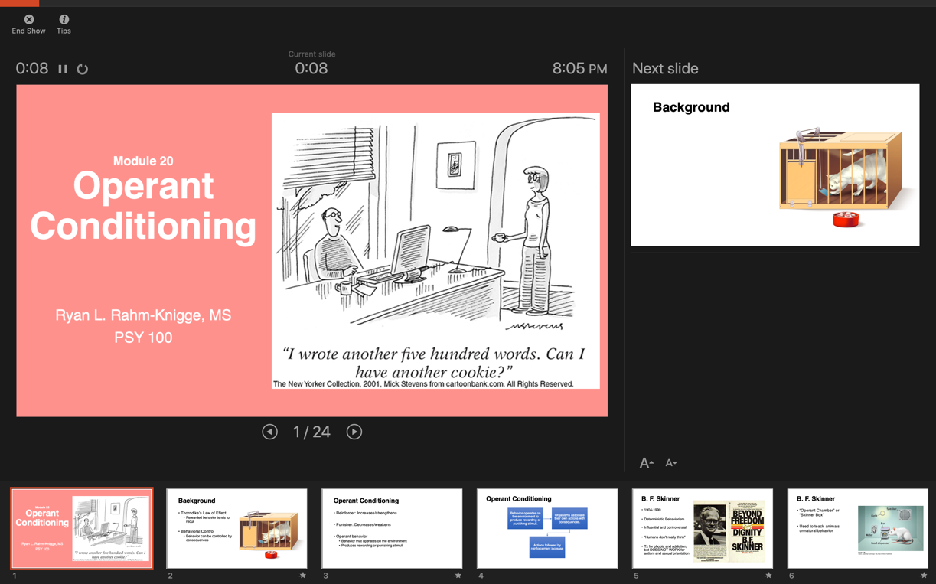

3. To pause an audio recording, press the pause button. It then changes to a triangle (play) button. Press that triangle (play) button to resume recording. The timer to the left tells you how long your recording is so far.
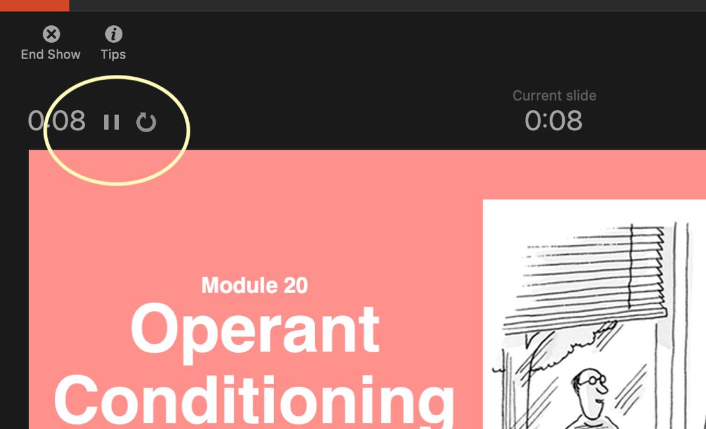

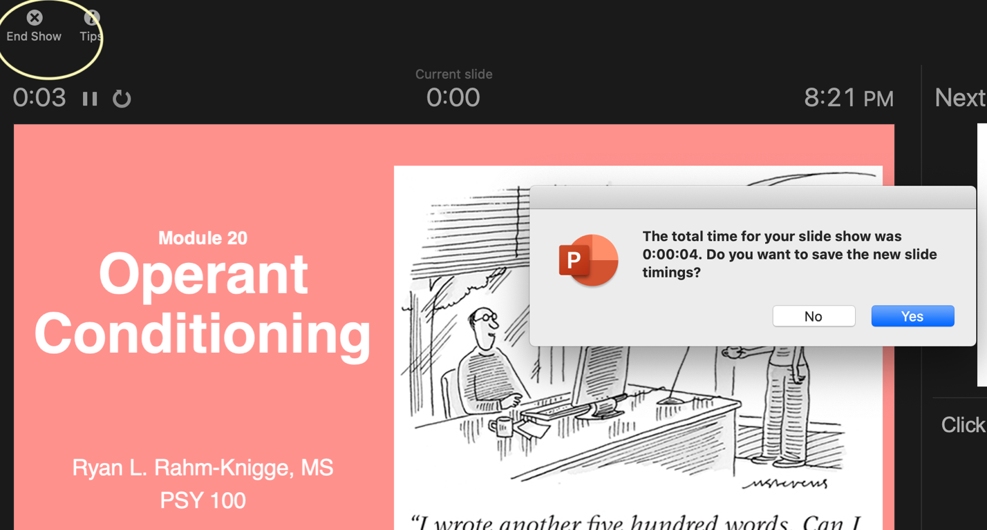
4. To end your recording, click End Show. Choose the default “Yes” for Do you want to save the new slide timings?

5. Save the entire recorded PowerPoint. Then, create separate files for each 10-minute PowerPoint file.
- The easiest way to do that is to copy the PowerPoint file several times.
- Leave 1 copy alone so it is the entire recording.
- Then, in the remaining files, keep only the slides that would make up a 10-minute chunk, and delete the rest. For example, you might have:
  - Master Operant Conditioning Lecture.pptx (the entire recording)
  - Operant Conditioning Lecture Part 1.pptx (slides 1-10)
  - Operant Conditioning Lecture Part 2.pptx (slides 11-20)…
- The audio recording of you teaching is anchored to each slide.
- You can test that this worked by going to Slideshow, Play from Start. You should see the slides play on their own with your audio recording (like a movie)
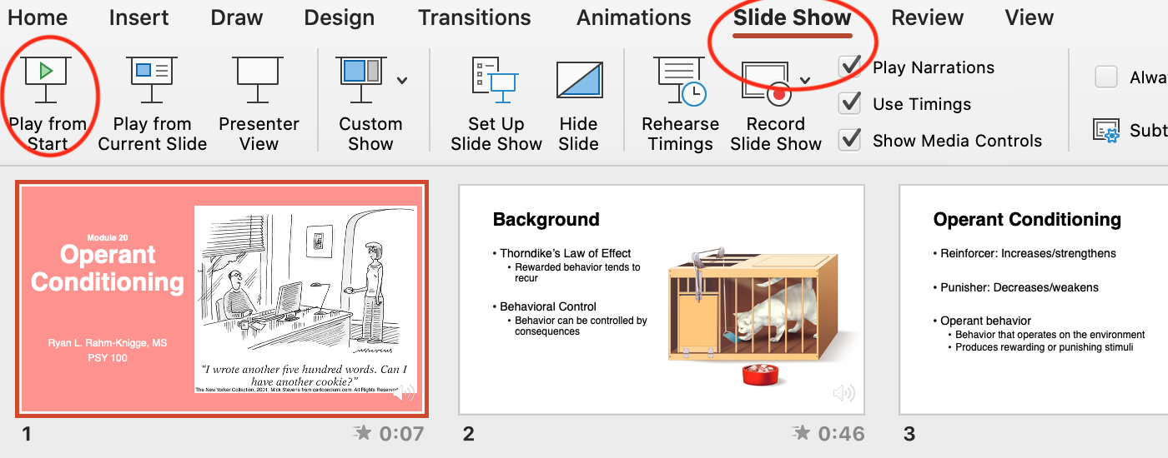

6. To export your recordings as videos, go to File, Export…
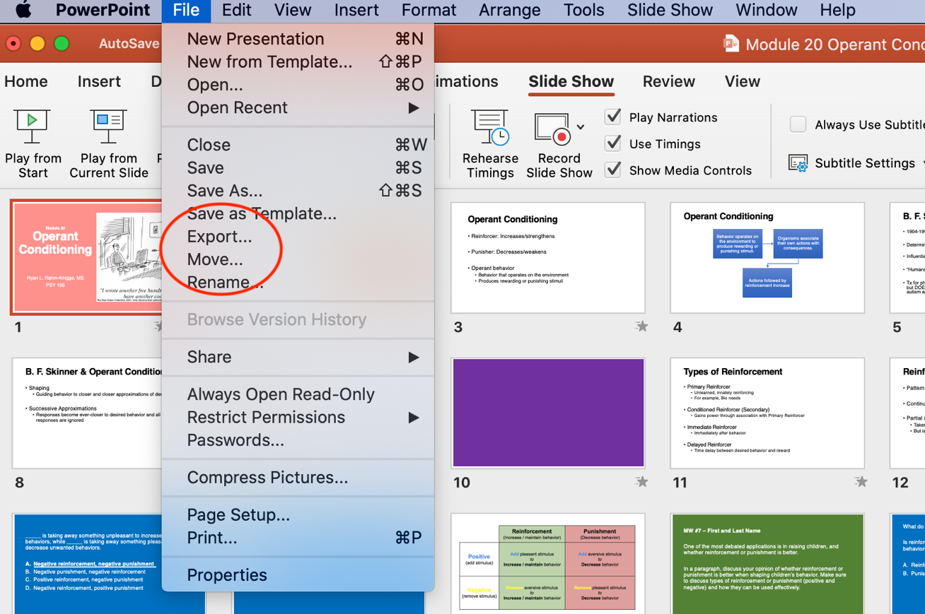

7. Choose Where and MP4…
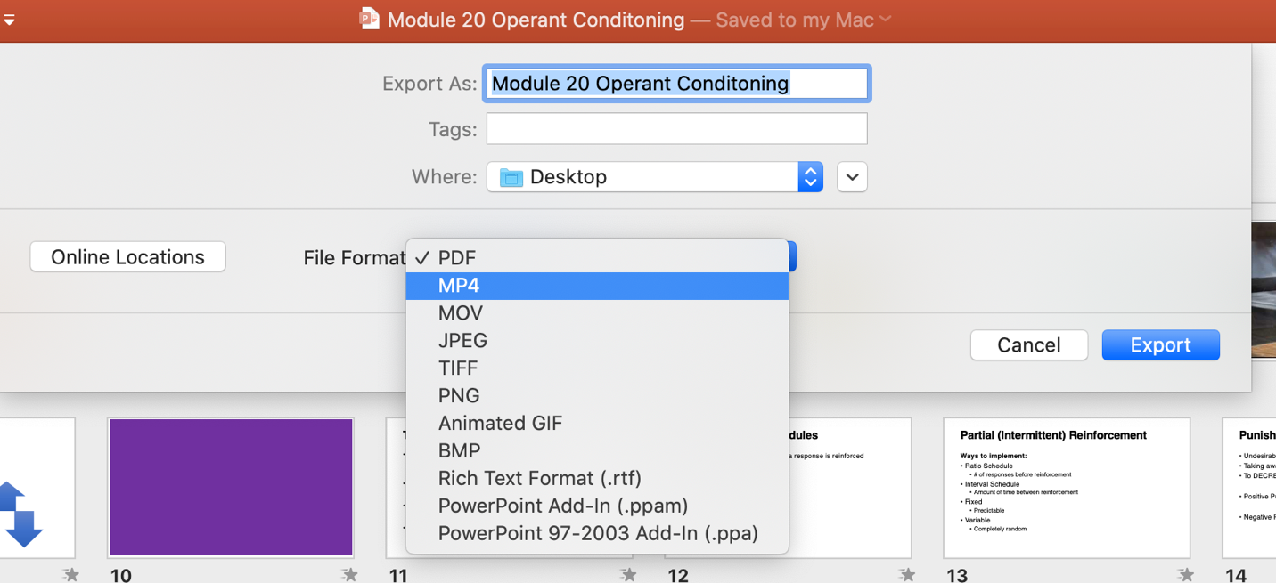

8. Then choose Low Quality
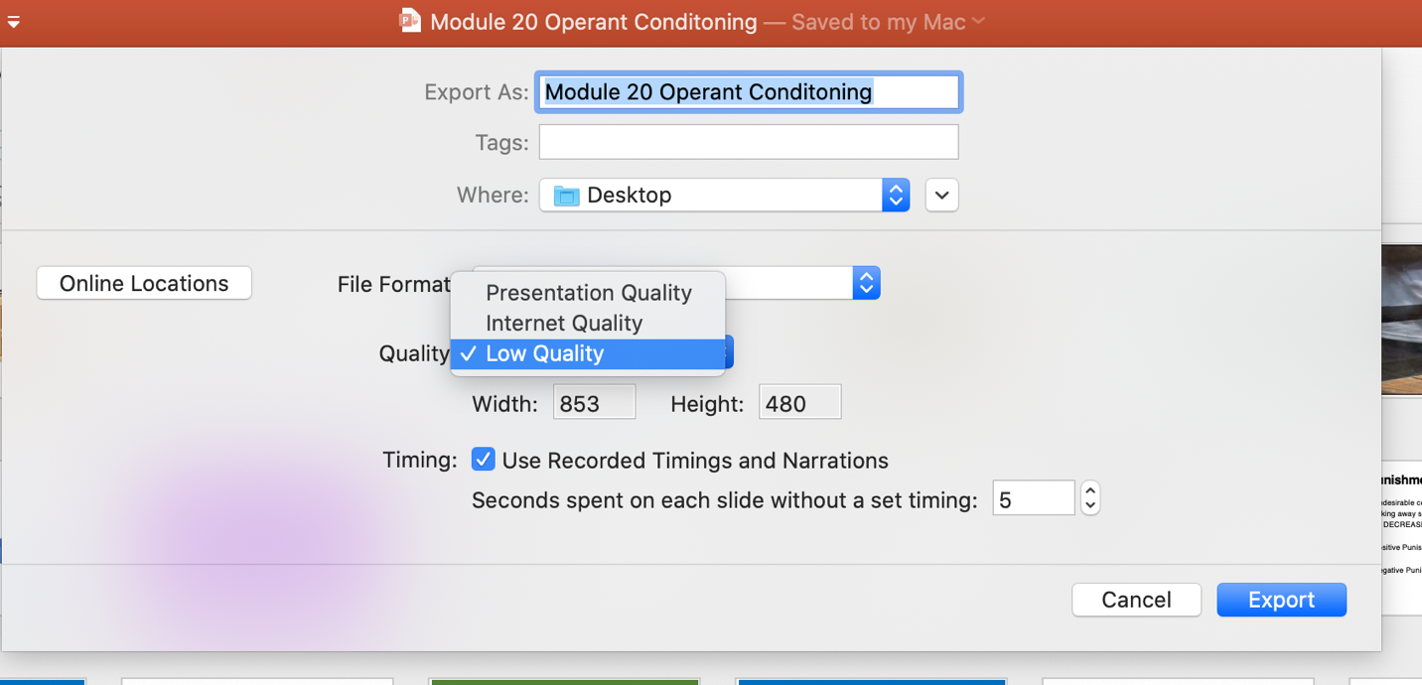

And now your PowerPoint recording is saved as a movie file that can be played by all
- Do this for each of the 10-minute PowerPoint presentations you created
- Keep a copy of the PowerPoint recording on your computer as a backup
- Upload a copy of the MP4 video to OneDrive (see the next section)

Step-by-Step Guide: Uploading Videos to OneDrive and Sharing with Students

There are a lot of ways to do this, but this is how I do it:

1. Log in to your CSU Office 365 account.

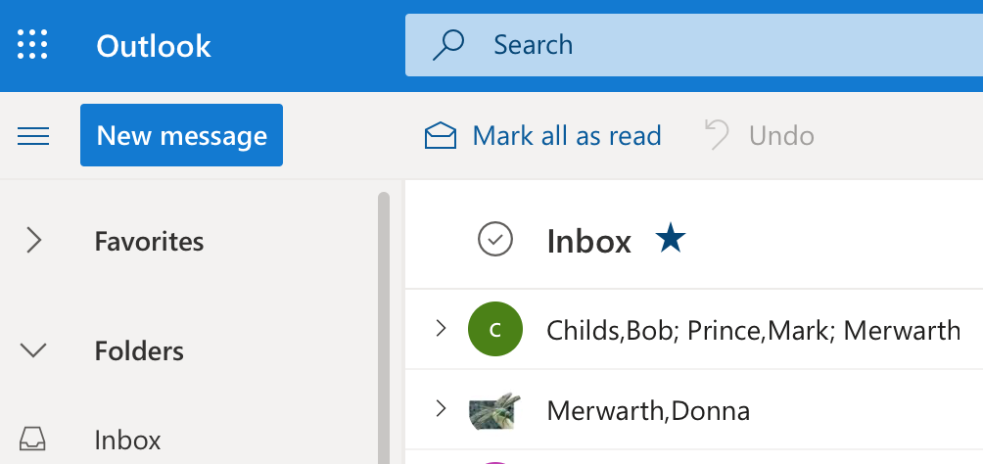

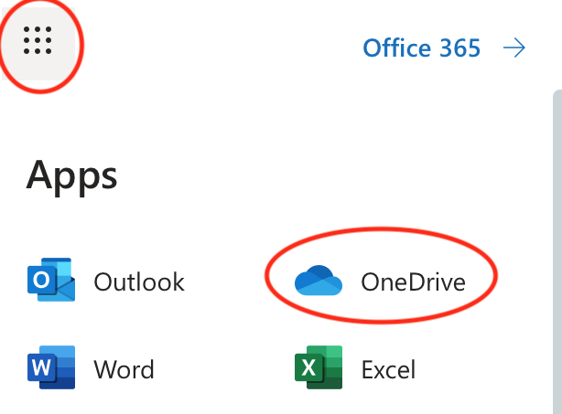
2. Click the dots icon and choose OneDrive

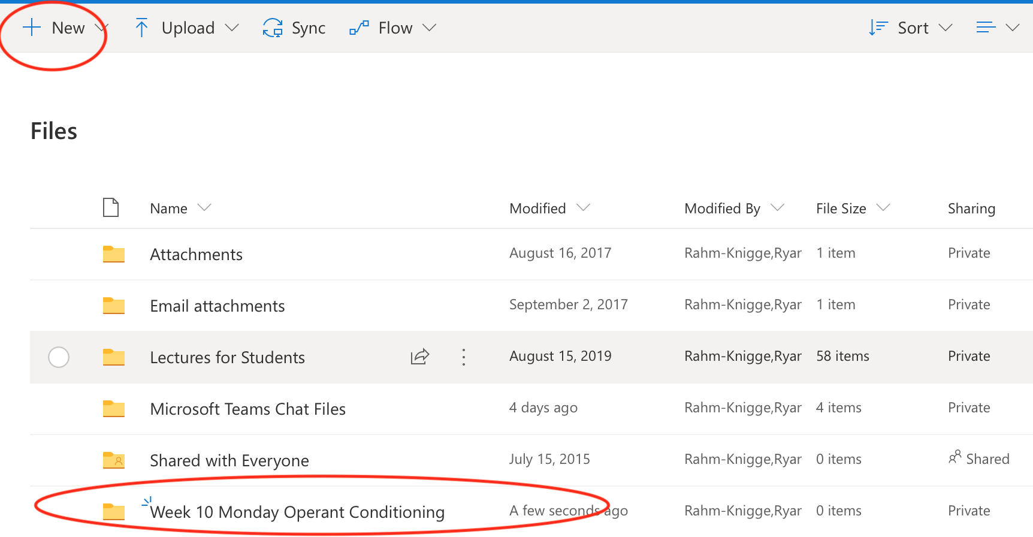
3. Create an organizational structure that is easy for students and aligns with your Canvas organizational structure. Use the New button to create folders. Keep things clean and easy for students to find. Assuming I teach MWF and this is Monday’s lecture, I called the folder Week 10 Monday Lecture Operant Conditioning.

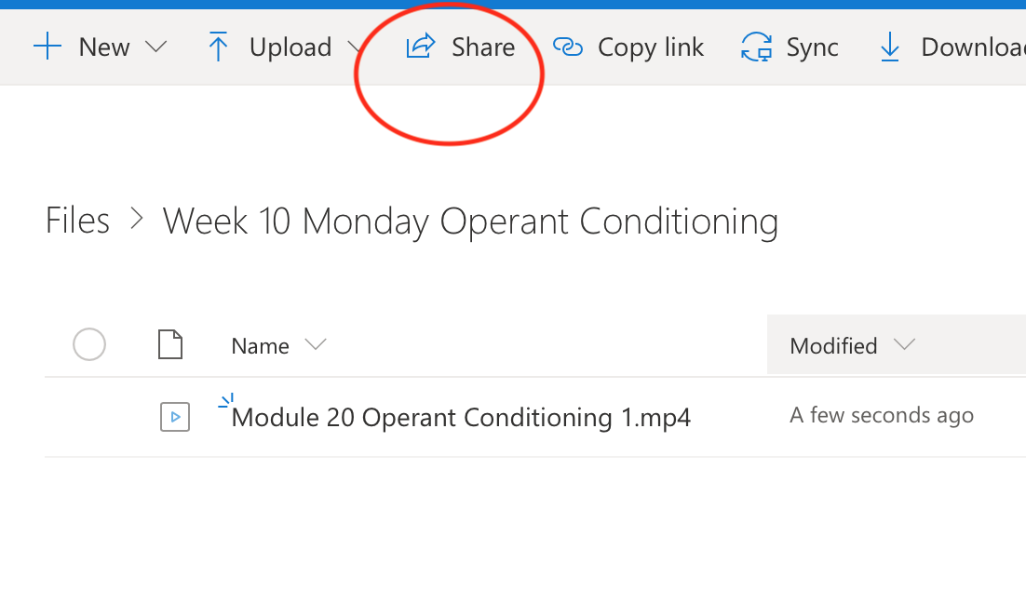
4. Upload the lecture videos you created into the appropriate folders. To share the contents of the folder, click Share

5. Click “Anyone with a link can edit”.
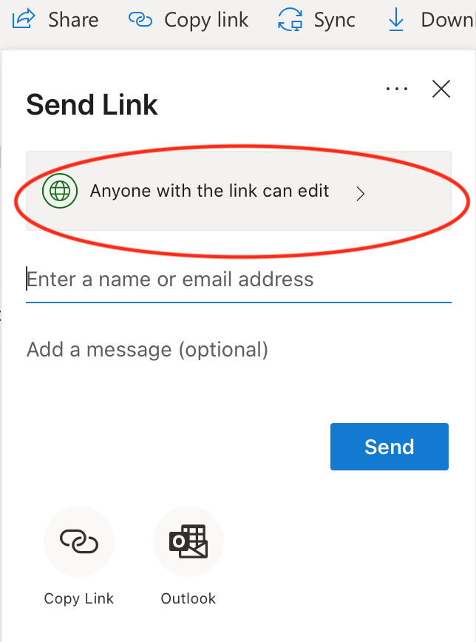

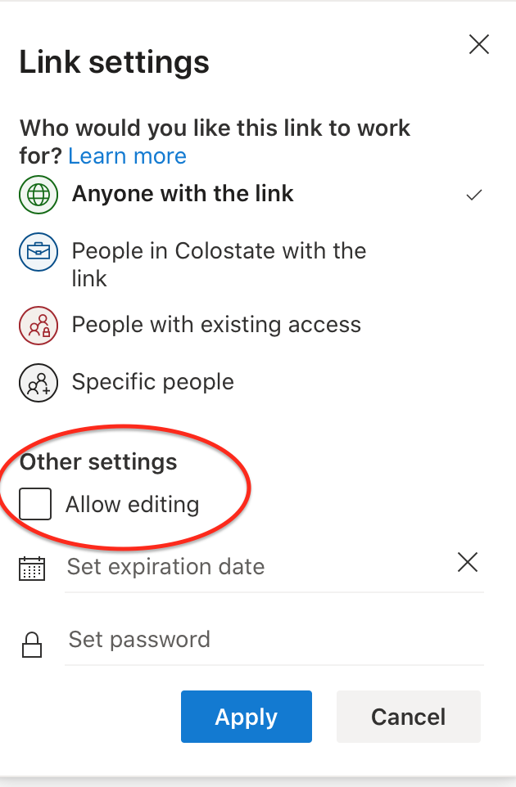
6. You can choose to leave it as “Anyone with the link” or among the other options (try to keep it easy for students to access – I’d probably leave it as this to reduce issues with student access). Uncheck “Allow editing”. Click “Apply”.

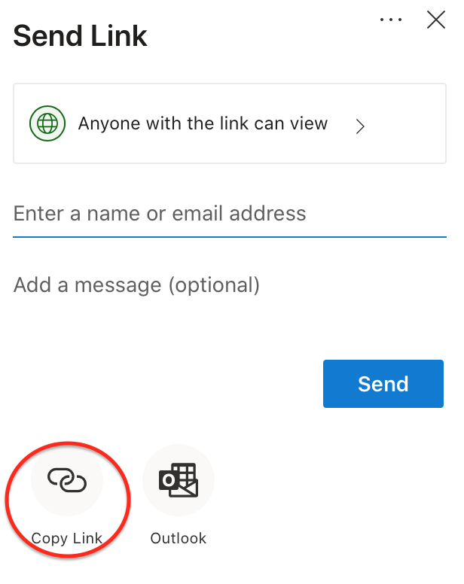
7. Click Copy Link

8. Copy and paste the link onto Canvas (in your well-organized folders where students can easily find the links they need – see the next section for instructions).

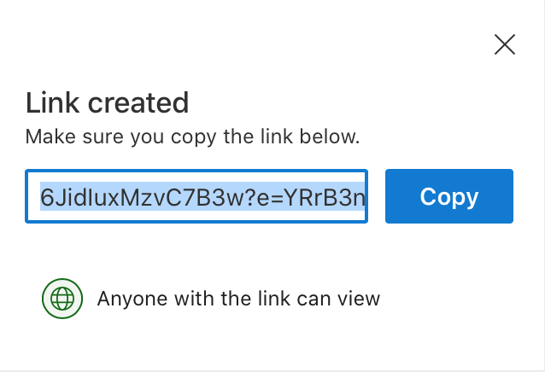

Posting Links on Canvas

To share links to OneDrive folders or links to Microsoft Teams meetings, follow these steps:

1. Go to “Modules” on Canvas. Go to (or create) your easy and organized folder system for the day/lecture/week. Click the “+” sign

In my example, I created a module for Week 10 where I will put all links, assignments, etc. This way, students know that everything for the week is in this folder for them.
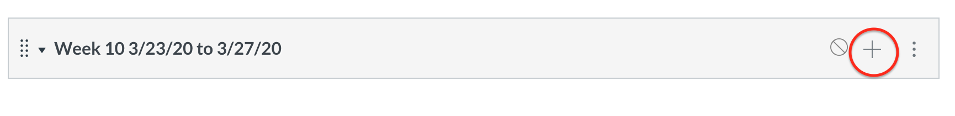

2. Choose “External URL”
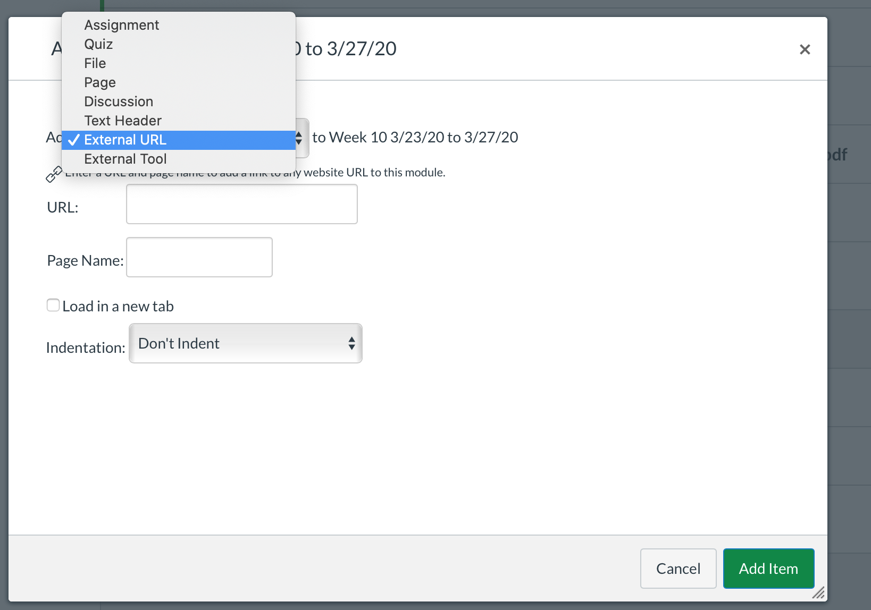

3. Paste the link in “URL”. Call it something clearly understood. For my link to the OneDrive folder with my operant conditioning lectures, I’ll call it “Module 20 Operant Conditioning Lecture Videos”. Click “Add Item”

4. Make sure to publish everything. When published, the “no” signs change to green check marks.
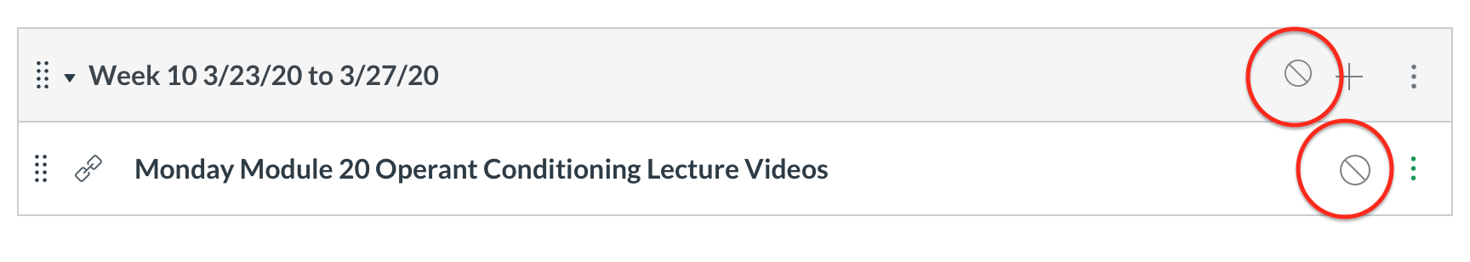

- For the livestreaming lecture links, call them something like “Monday Module 20 Livestream 10:00am”.
  - If you consolidated your 2 sections into 1 section on Canvas, have two links:
  - “Monday Module 20 Livestream 10:00am”
  - “Monday Module 20 Livestream 11:00am”
  - It really does not matter if students join their correct section. What matters is that you hold livestream sessions only during your regularly scheduled lecture time.

- After you have livestreamed the lecture, delete the links to keep the folder clean

- You can post the livestream recordings in the same OneDrive folder as the other lecture videos, that way you don’t have to create so many links. In OneDrive, call them something students can find easily, like “Module 20 Operant Conditioning Livestream Video”

Livestreaming Lectures

Recommendations

- Use Microsoft Teams.
  - Students have access to this through the Office 365 account
  - MS Teams is supported by the university
  - MS Teams is available on mobile devices

- Schedule the meeting and post the link well in advance of the scheduled lecture time.
  - Start the livestream 10 minutes early so students can join and settle in

- Record the MS Teams livestream with captions.

- Stream pre-recorded PowerPoint lectures.

- Interact with students via chat and/or webcam while streaming.
  - Interact – point out what’s important, add notes, answer questions, have students do iClicker quizzes
  - Try to provide our excellent PSY 100 classroom experiences

- Students can see and hear you during the livestream.
  - Dress appropriately
  - Be in a private or quiet area (your mic and camera will pick up whatever is happening around you)
  - Pause the pre-recorded videos, don’t talk over them

- Ask students to mute their mics and webcams

Step-by-Step Guide: Livestreaming Lectures and Running Meetings on Microsoft Teams

1. Download MS Teams

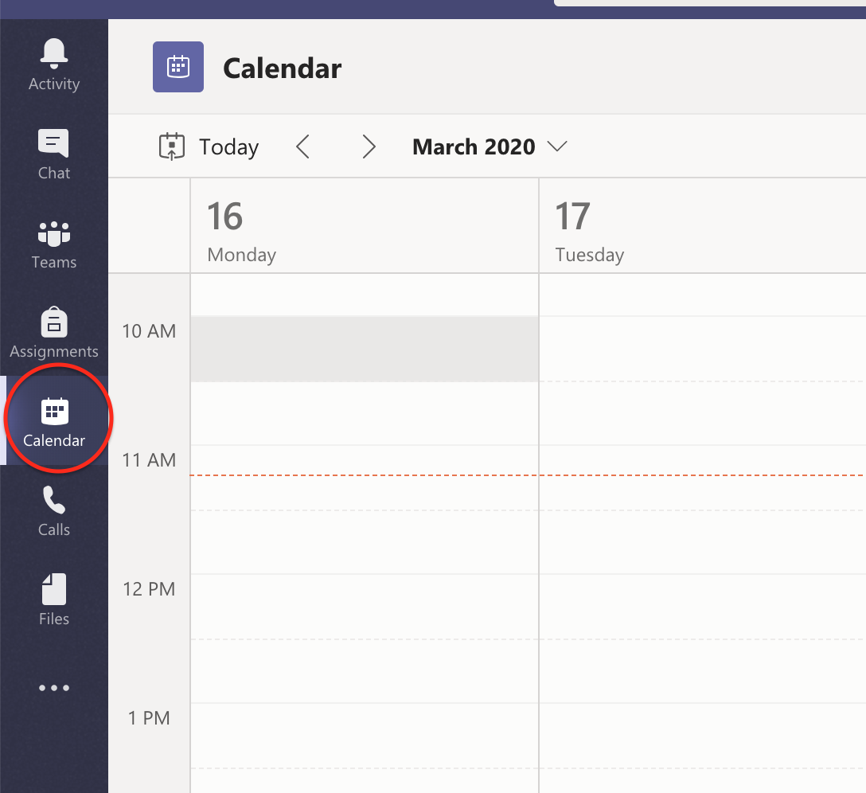
2. Click “Calendar”

3. Click “+ New Meeting”. Or, select the date/time you want the meeting to be in the calendar. Either way, you’ll get the meeting details box.
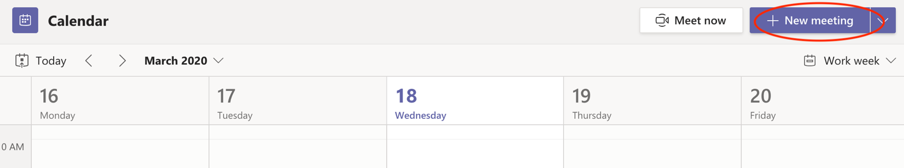

4. Fill out the details of your meeting. Click “Send” when done.
- Students might have multiple classes running Teams meetings, so it’s helpful to include “PSY 100” and the name of the module lecture.
- You must include a person in the “Add required attendees box” in order to get a link you can send to students. Please invite me. Do not invite students. In my example, I invited Donna because I cannot add myself. Please do not invite Donna to your classes.
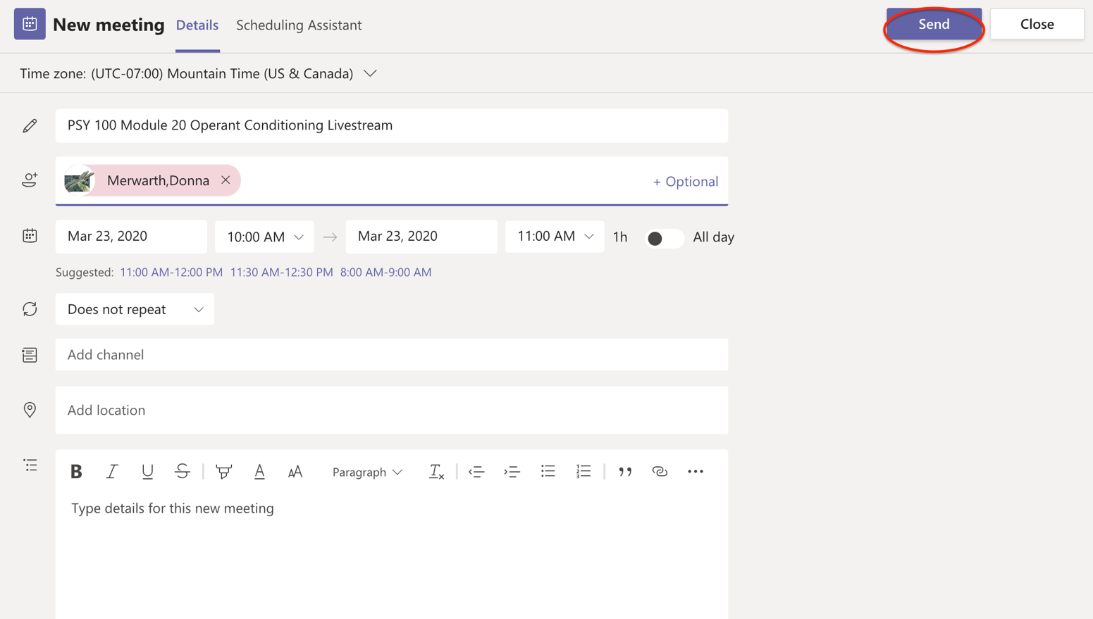

5. Your lecture will now show up on your calendar (and mine, because you’ll invite me).

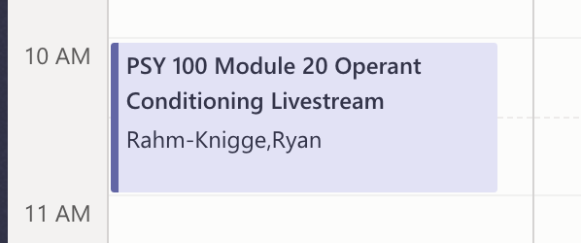

6. Click on your scheduled meeting to open the details page again. At the very bottom, you will find text “Join Microsoft Teams Meeting”. Right-click this text to copy the link.
- This is the link you will post on Canvas (see the section Posting Links on Canvas in this guidebook)
- Anybody with the link can join the meeting

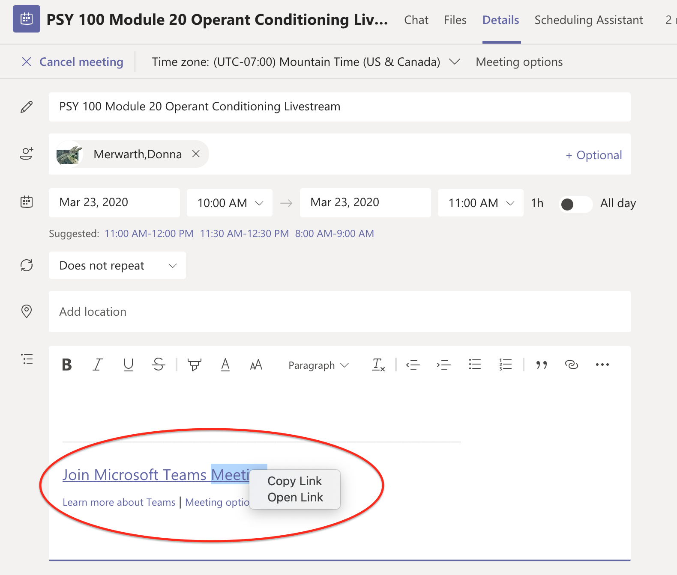

Lectures on MS Teams and Responding to Students

THIS HAS BEEN UPDATED! If you have the previous versions of this document, this new process is much easier.

Also, remember to ask students to turn off their mics and webcams. Even if students stay quiet, their mics left on can cause static sounds.

1. In the meeting details page, click “Join”
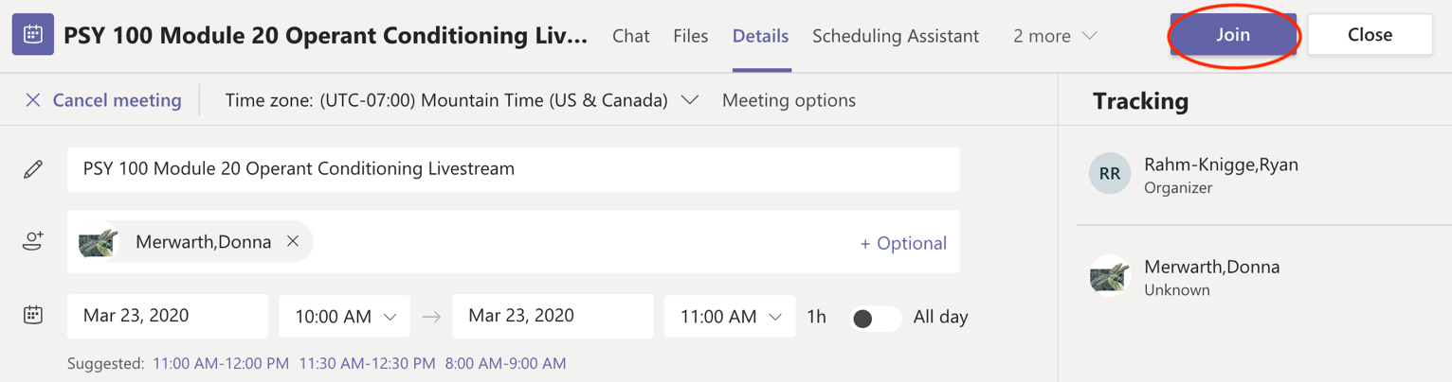

2. You’ll get this screen. Click “Join Now”.
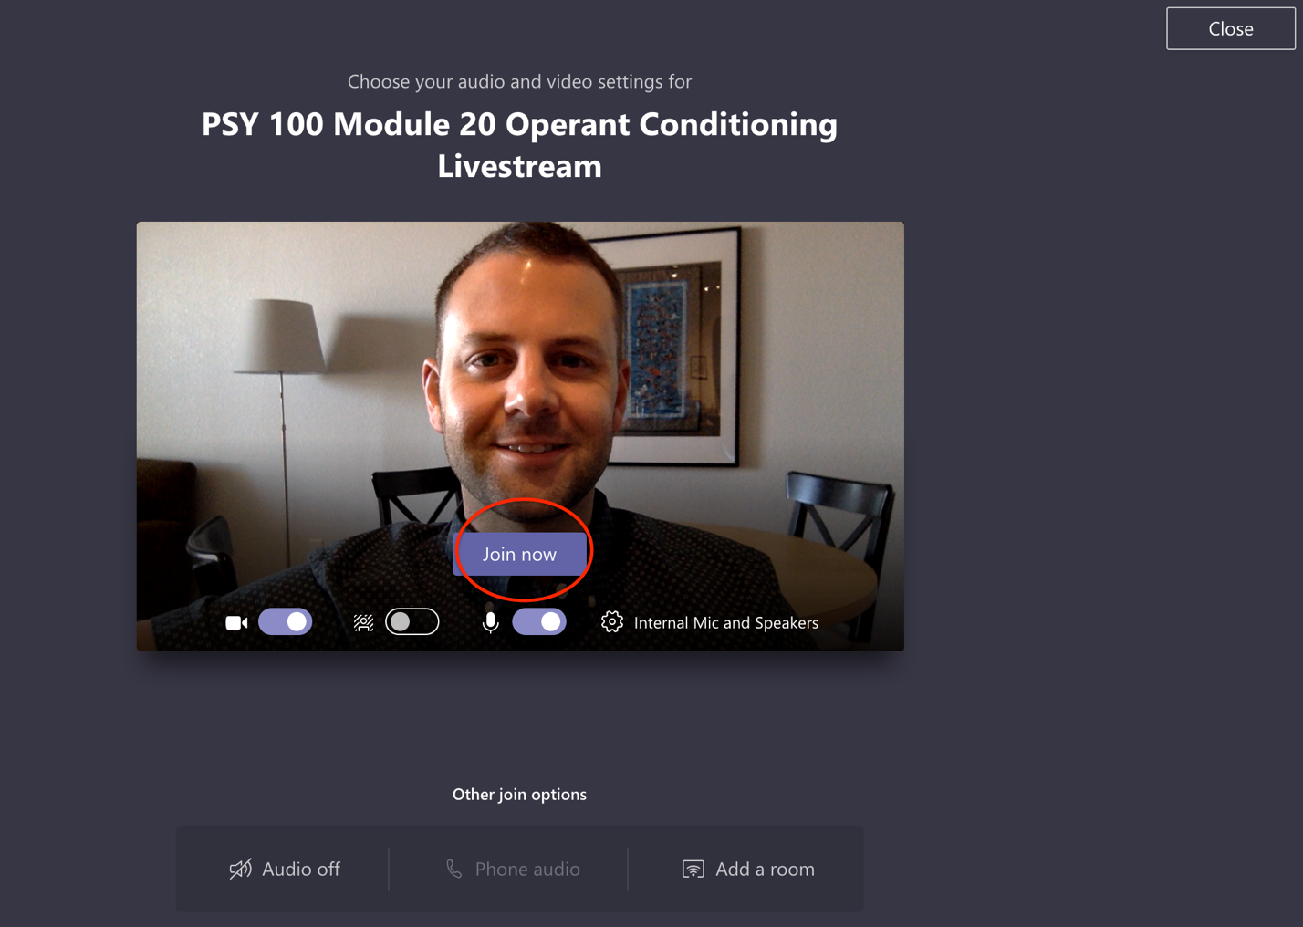

3. Click the “More Actions” triple dots to “Turn on live captions”, “Turn off incoming video” (unless you want to see students’ webcams) and “Start recording”. Then, click the chat icon beside the triple dots to enable text chat with students. You can use the “Show Participants” icon beside the chat icon to see who has joined the livestream.

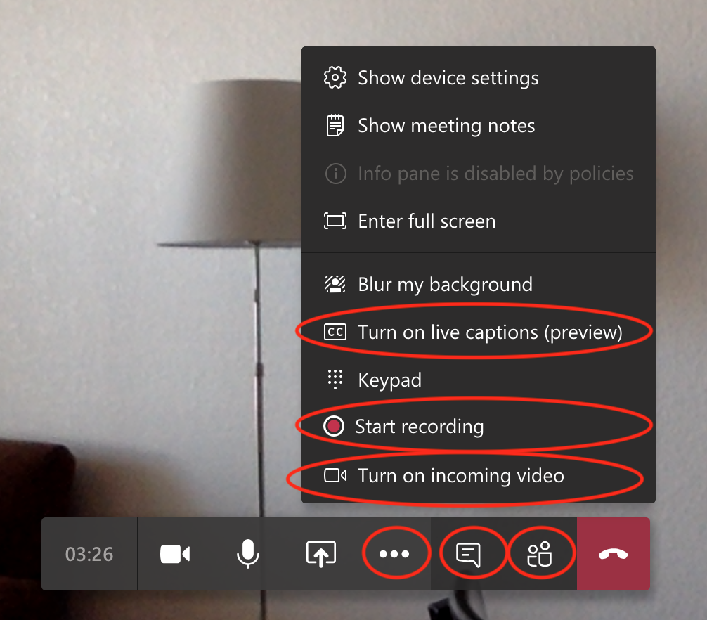

5. After setting up all of the above options, click the “Share” icon.

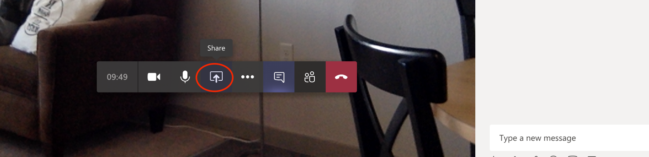

6. Beside “PowerPoint”, click “Browse”. If your pre-recorded master PowerPoint lecture (the file with all of the audio recorded slides) is saved to your computer, click “Upload from Computer” find it where you saved it. Alternatively, you can upload you PowerPoint to OneDrive and open it by clicking “OneDrive”. If you have a PC, you might have a check box “Include system audio” – click that.

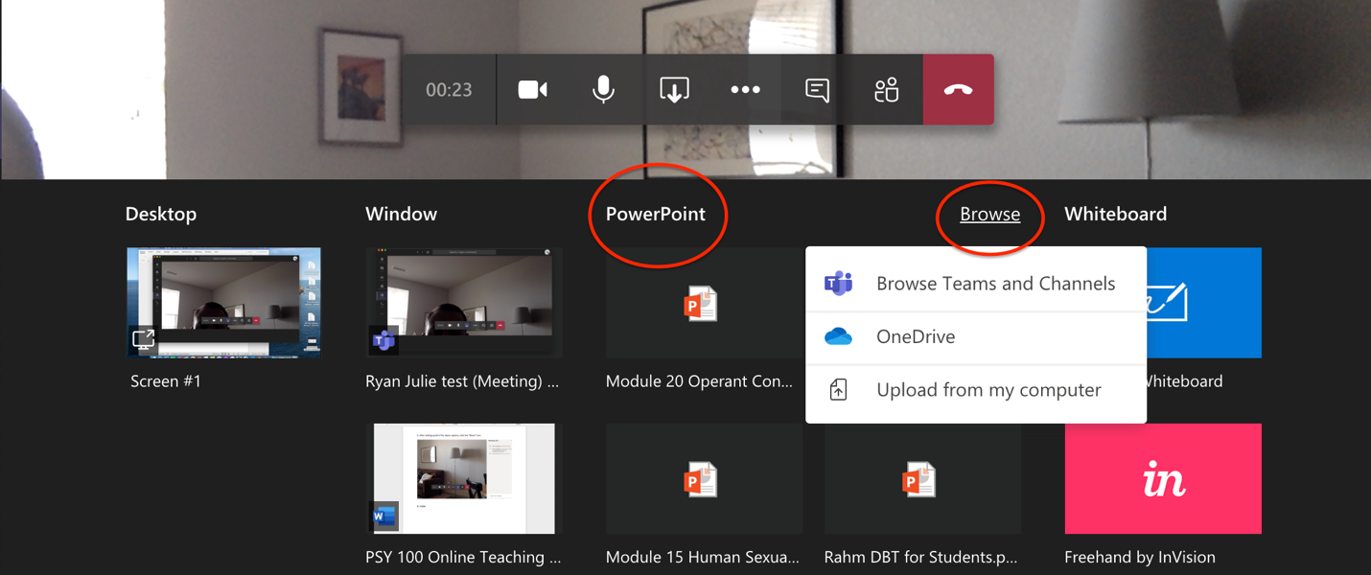

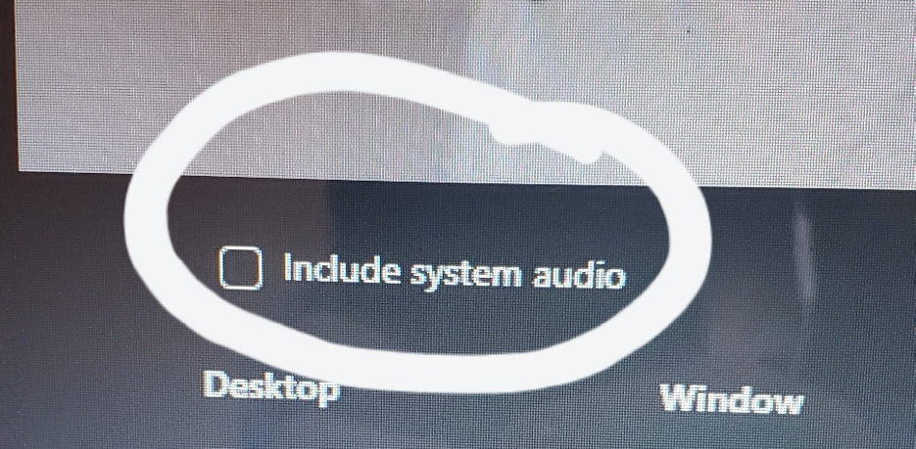
7. Your PowerPoint slides and audio will auto-play. If your webcam and mic are still on, students can see and hear you. I highly recommend turning them off until you need them on.
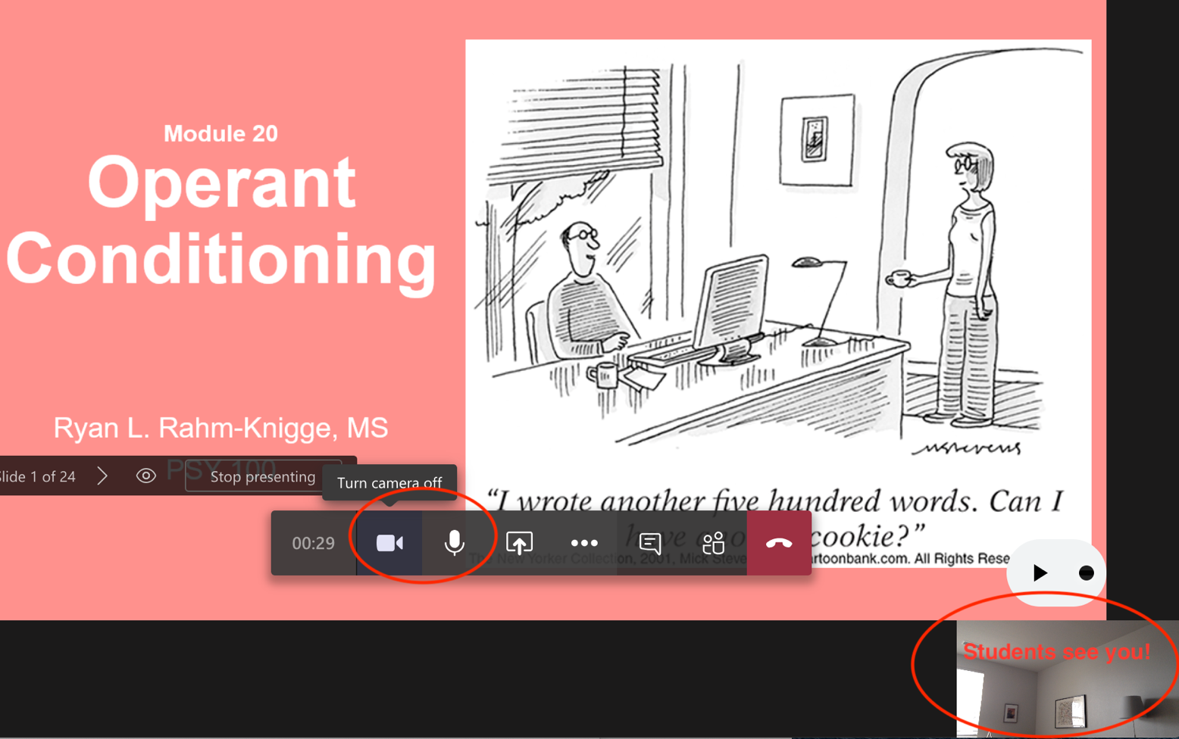

8. To pause the PowerPoint slides (to explain a concept more, take questions, etc), hit the Pause button. Remember to turn your mic and webcams back on if you turned them off. At the end of lecture, click “Stop presenting”. To disconnect/end the meeting, click the red phone button.
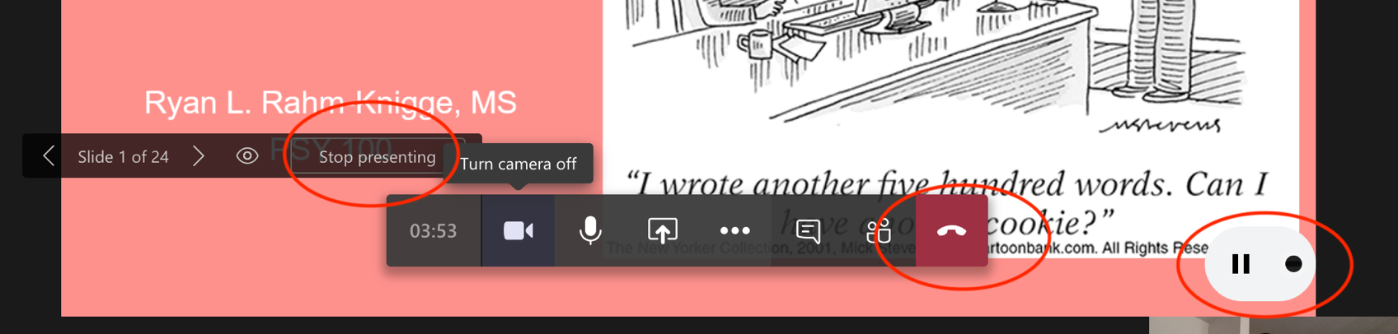

9. The recording of the livestream can take 24 hours to process and be made available.

Office Hours

You can choose to maintain your current office hours or switch to appointment only.

- If you change your office hours or switch to appointment only, please post the update in your syllabus (and reupload) and post on a Canvas announcement
  - Include how students should contact you or join office hours
  - Remember, office hours should be online

- Consider using MS Teams for office hours to help students continue to be familiar with it for lectures
  - However, not all students will have reliable internet access

- Consider additional services for students who may not have good internet access
  - Instant messaging (Skype?), texting (Google Voice?), phone calls
  - These are unlikely to be FERPA compliant, so be careful what information you are sharing and how

Exams

General Recommendations
- We will use Canvas Quizzes for the unit exams and final exams
- We won’t use ProctorU

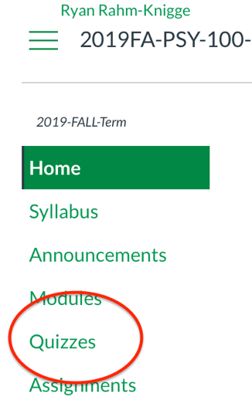
Step-by-Step Guide: Writing Multiple Choice Exams on Canvas
- Code exams onto Canvas under “Quizzes”
  - Expect writing exams on Canvas to take a long time.
  - Please do not wait until the day of the exam to do this!

- Name your exams what they are called in your syllabus

- In “Quiz Instructions”, you can add the honor pledge
  - Don’t force students to agree, but it’s a good prime
  - Also, tell students what the password is here

- I recommend the below settings (see screenshot below)
  - “Quiz Type”: Graded Quiz
  - “Assignment Group”: Whatever your placeholder is for exams in the Assignments section. Mine is called “Exams”
  - Set the time limit. I taught 50-minute classes, so the time limit is 50 minutes.
    - Set this for everyone – the next subsection has a link to instructions to add extended time for accommodations
  - Uncheck “Allow Multiple Attempts”
  - Check “Show One Question at a Time”
    - Uncheck “Lock Questions After Answering” – they should be able to go back and change their answers, just like a paper exam
  - Check “Require a Password”
    - Make the password easy – this is just so students don’t accidentally start the exam before they intend to. Post the password in “Quiz Instructions”
  - Uncheck “Filter IP Addresses”

- Assign the quiz to Everyone and set the dates
  - Even for people with accommodations. See the next subsection on how to give students with accommodations extended time.
  - Please give students several days to complete the exam. DO NOT REQUIRE STUDENTS TO TAKE THE EXAM ONLY DURING SCHEDULED CLASS TIME.
    - Students are going to have tech problems and life issues.
  - “Due” is the date students must have it done by. “Available From” is when students can start taking it. “Available Until” is the last day/time students can access it. I think it’s easiest to make the “Due Date” and “Available Until” date the same.
Settings Screenshot:
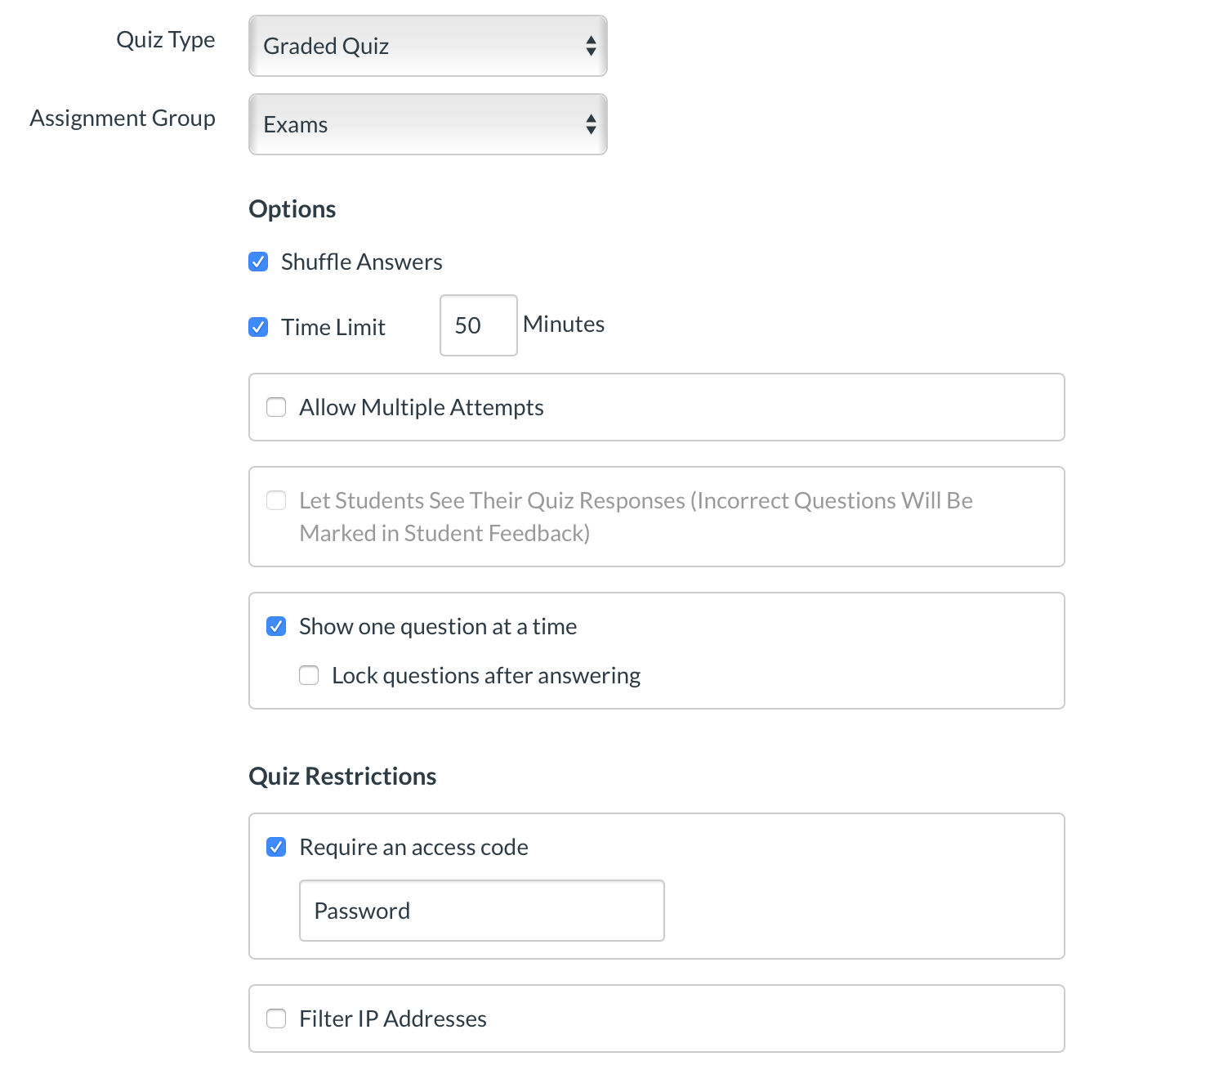

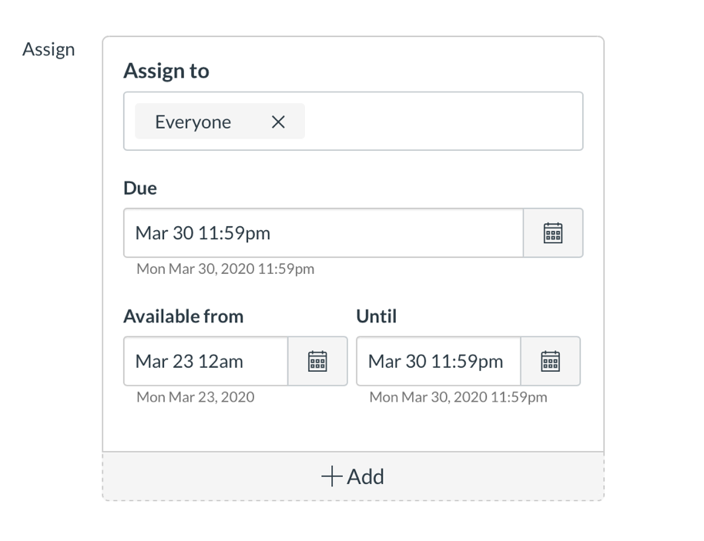

6. Add questions to your exam

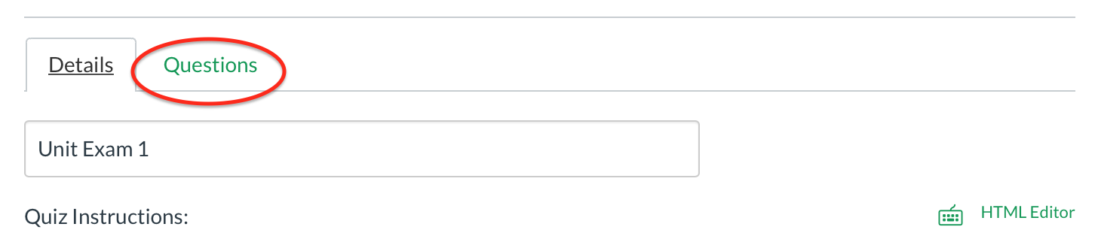
Step 6 Part 1:

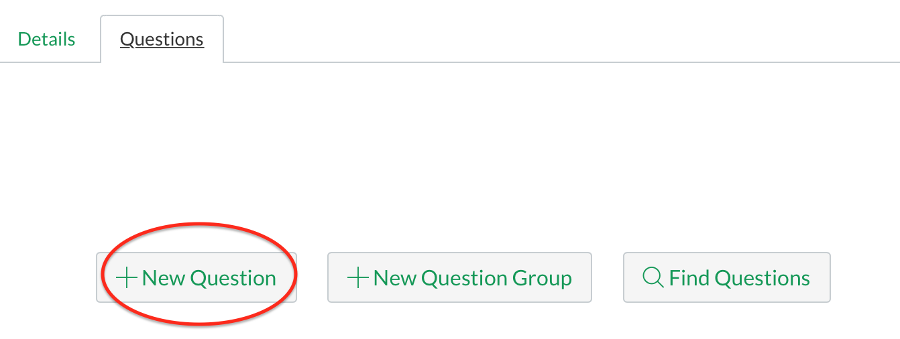
Step 6 Part 2:

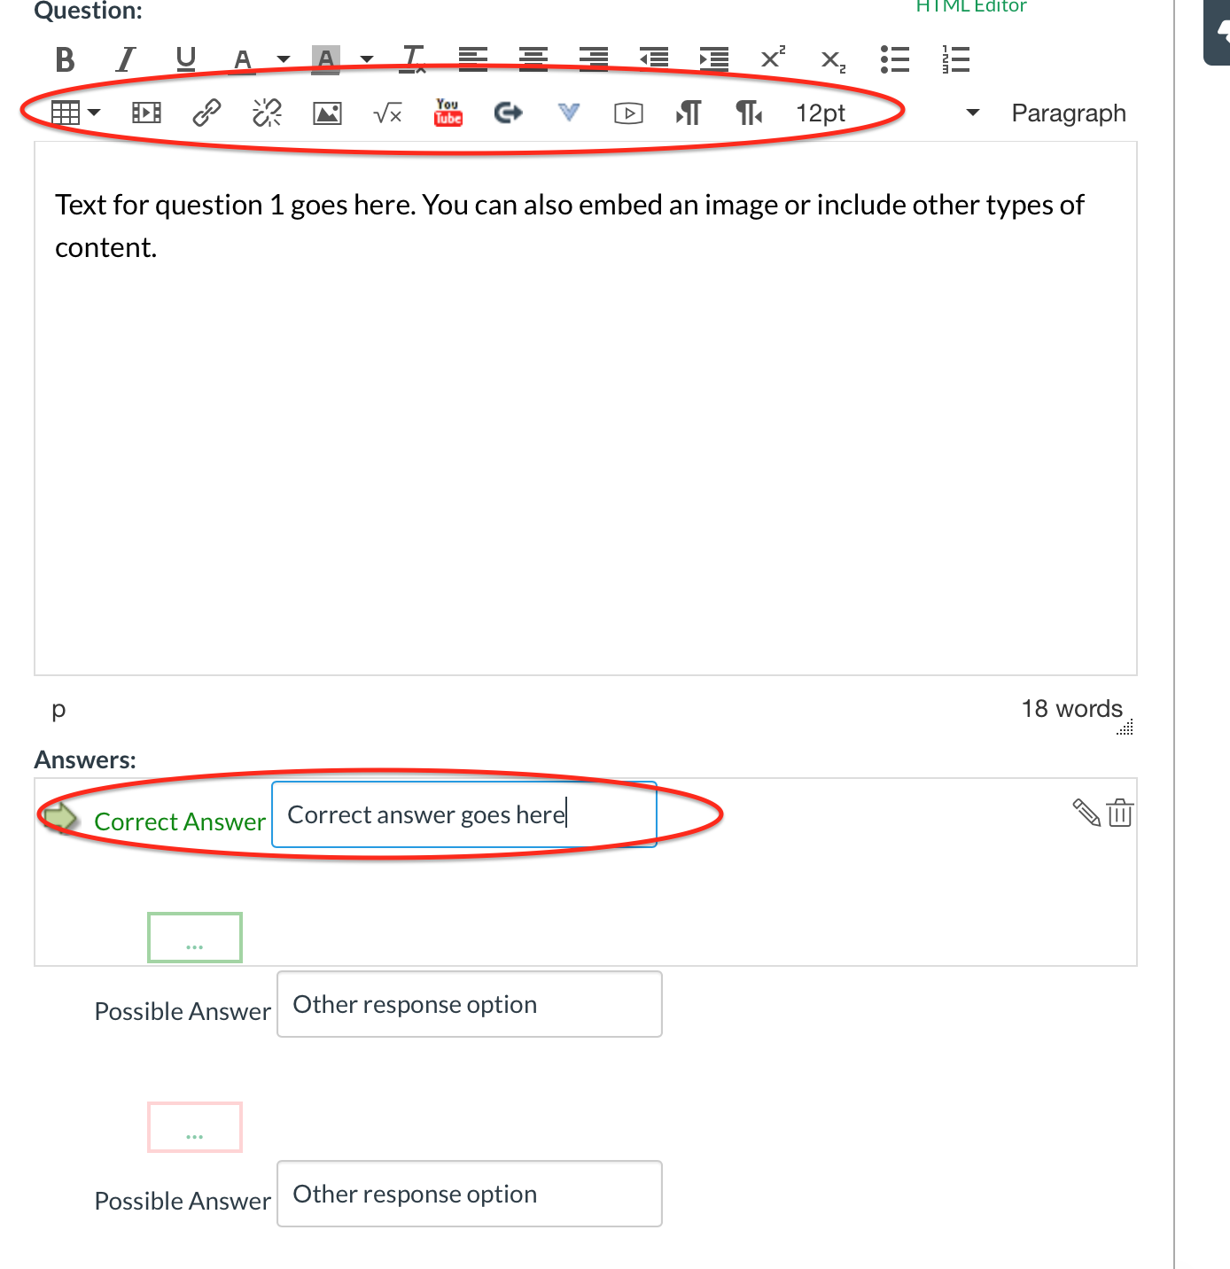
Step 6 Part 3:

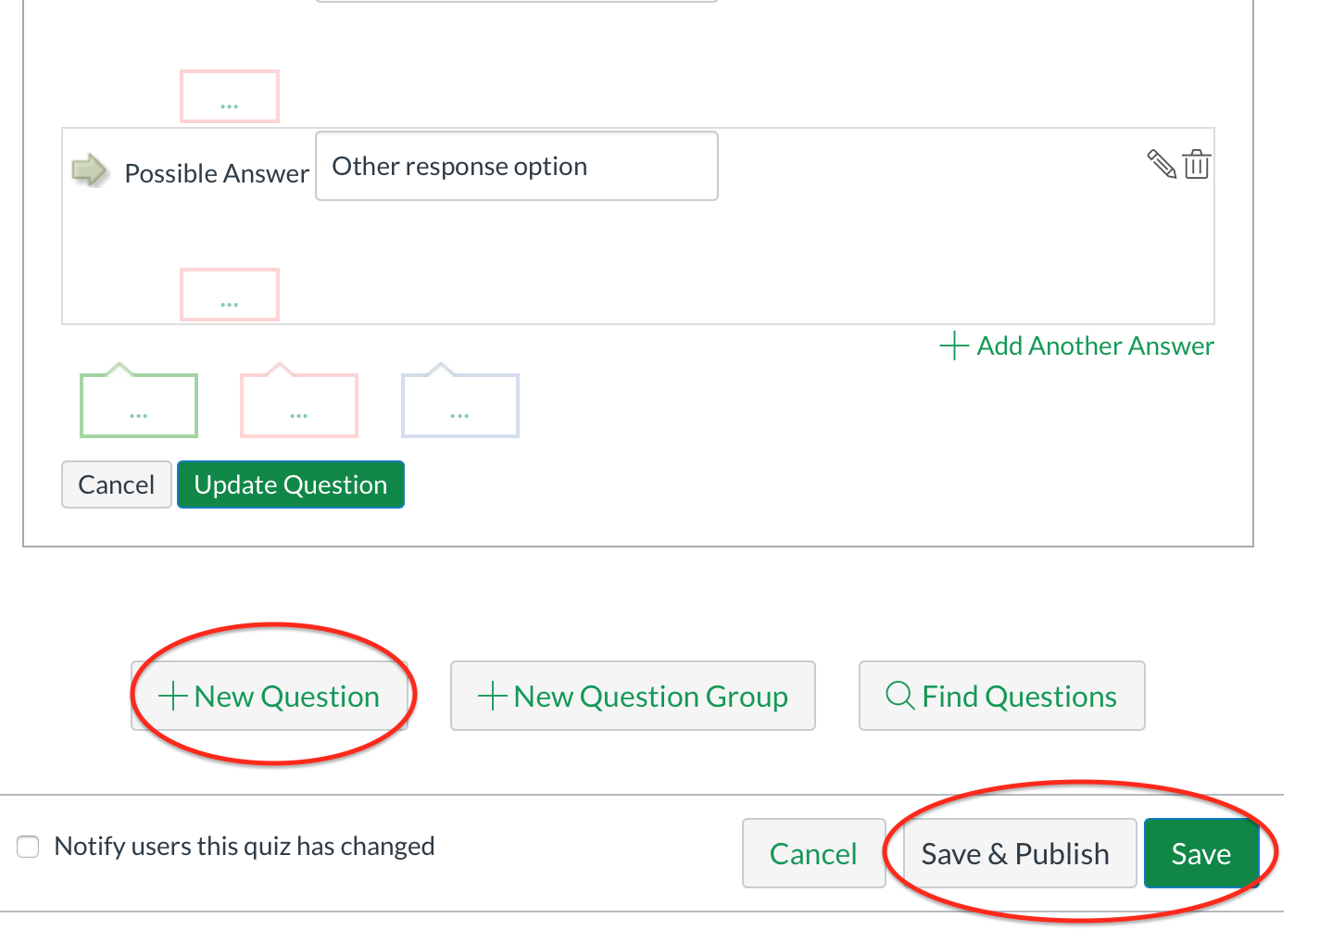
7. When you’re done writing the question, click “Update Question”. To add more questions, click “+ New Question”. When you’re done, choose “Save” if you want to wait to publish, or “Save and Publish” if you’re ready for it to go live (on the start date you entered in Step 5).

Assigning Exams and Creating Extended Times for Students with Accommodations

WE MUST PROVIDE ACCOMODATIONS TO STUDENTS WITH SDC ACCOMMMODATIONS.

Canvas has created a guide to providing extensions to specific students at the link below. This seems easier than trying to manage the “Assign to” section.

https://community.canvaslms.com/docs/DOC-13053

After you publish the quiz, you can:
- Open it
- Click “Moderate This Quiz”
- Search for and select individual students for whom you want to change the quiz
- Provide extended time in minutes
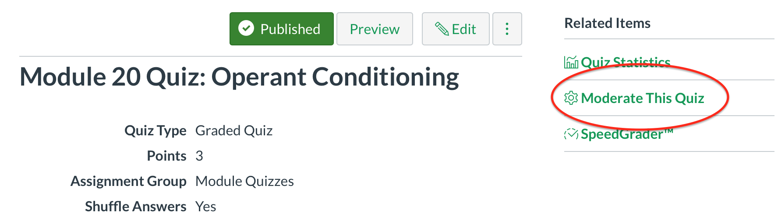

Research Participation

- Students who are in Option A and have started participation should continue with Option A
  - Donna and research teams are working to put more studies online – please reassure your students of this

- Students who are in Option A and have not started participation can switch to Option B. Their Option B due date is the last day of classes.

- Students who are in Option B have a due date coming up.

- Donna and I will monitor the Option A slots. We will discuss how we can handle this later in the semester.

- If students ask you questions or bring up concerns about research, please do not direct students to Donna directly. Any requests to Donna for changes or problem-solving should come through the instructor.

- Do not yet offer students an alternative assignment for research participation.

- Please discuss case-by-case issues about student research participation with me.

- This section will be updated and redistributed anytime Donna provides updated information.

Extra Credit iClicker Quizzes on Canvas

The General Idea

To add iClicker questions as Canvas Quizzes:
- Set up a graded Survey Quiz (see instructions below)

- Assign each quiz whatever your grading scheme is for a lecture’s iClicker participation
  - In my classes, clicking in 1+ times during the lecture (even if the answer was wrong) entered a total of 1 point into the iClicker gradebook.
  - At the end of the semester, I chose 10 random days. Students received 1 extra credit point per day they clicked in (up to 10 points).

- The rest of the steps fit the grading scheme I described above. This sounds like a lot of steps but it’s only a couple more than what we had been doing in previous semesters:
  - Make each iClicker Canvas Quiz worth 1 participation point
  - Mute the iClicker Canvas Quizzes in the gradebook so students do not see the grade
  - At the end of the semester, download your Canvas gradebook into Excel
  - You can paste in the iClicker gradebook columns if you want
  - Add up the iClicker points you’re assigning (whether random days, just getting to 10 points, etc)
  - In Canvas, delete the iClicker Quizzes so they disappear from your gradebook.
    - You have the grades downloaded in the Excel file
    - Keeping the quizzes on Canvas might make them show up as non-extra credit points when you post final grades.
  - In your iClicker Extra Credit column on the gradebook, enter the total iClicker extra credit points you calculated for each student

- Unfortunately, for extra credit, it’s not as easy as coding Canvas to drop the __ lowest or only count the __ highest scores (like we do for exams if we drop the lowest exam grade or LauchPad quizzes if we only have a certain portion count towards the grade).
  - This is because Canvas doesn’t factor in that the iClicker quizzes are technically worth 0 points of the total course points due to being extra credit.
  - So, if we leave the iClicker columns in the gradebook, it will make the grade out of 10 points in my example (or however many points in your grading scheme), adding points to the total grade.

On the next page, see a Step-by-Step Guide for setting up the quizzes in Canvas.

Step-by-Step Guide: Extra Credit iClicker Quizzes on Canvas

1. Create a quiz

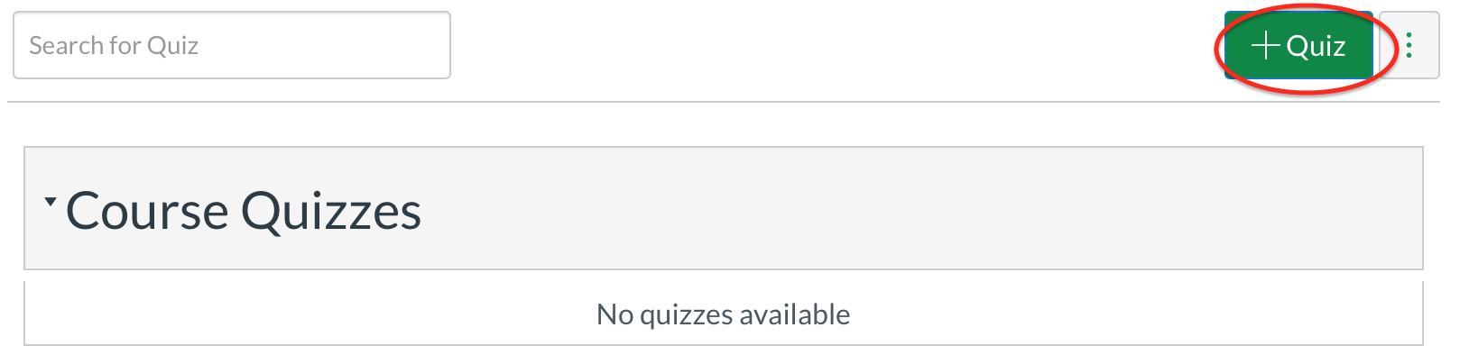

2. Name your quiz so that students can easily identify which lecture it goes with
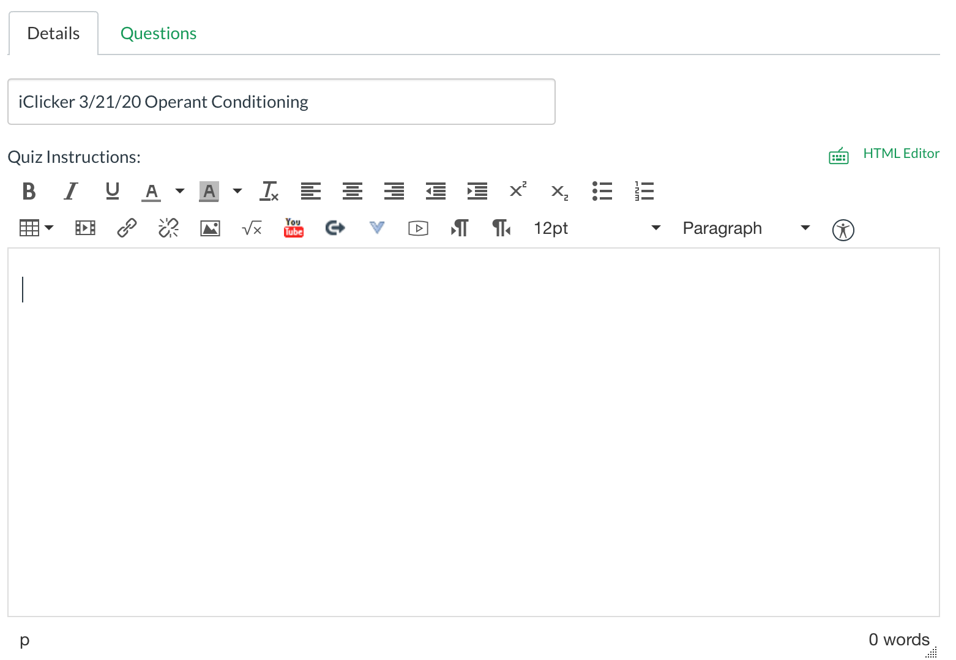

3. Change options:
- Set the quiz type to Graded Survey.
  - This type of quiz gives students whatever # of participation points you indicate regardless if students get the question right or wrong.
  - This is helpful if you give extra credit like I did (just clicking in, regardless of answer) and for questions that are more interactive or opinion.
- Change the Assignment Group to where it makes sense in your Canvas organization. I would create one just for iClicker quizzes (in my example Canvas page, I didn’t set one up).
- Assign points (in my grading scheme, 1 point for the whole quiz)
- If you’re using iClicker questions as content review, allow multiple attempts and/or for students to see the correct answers. This provides some opportunity for corrective feedback.
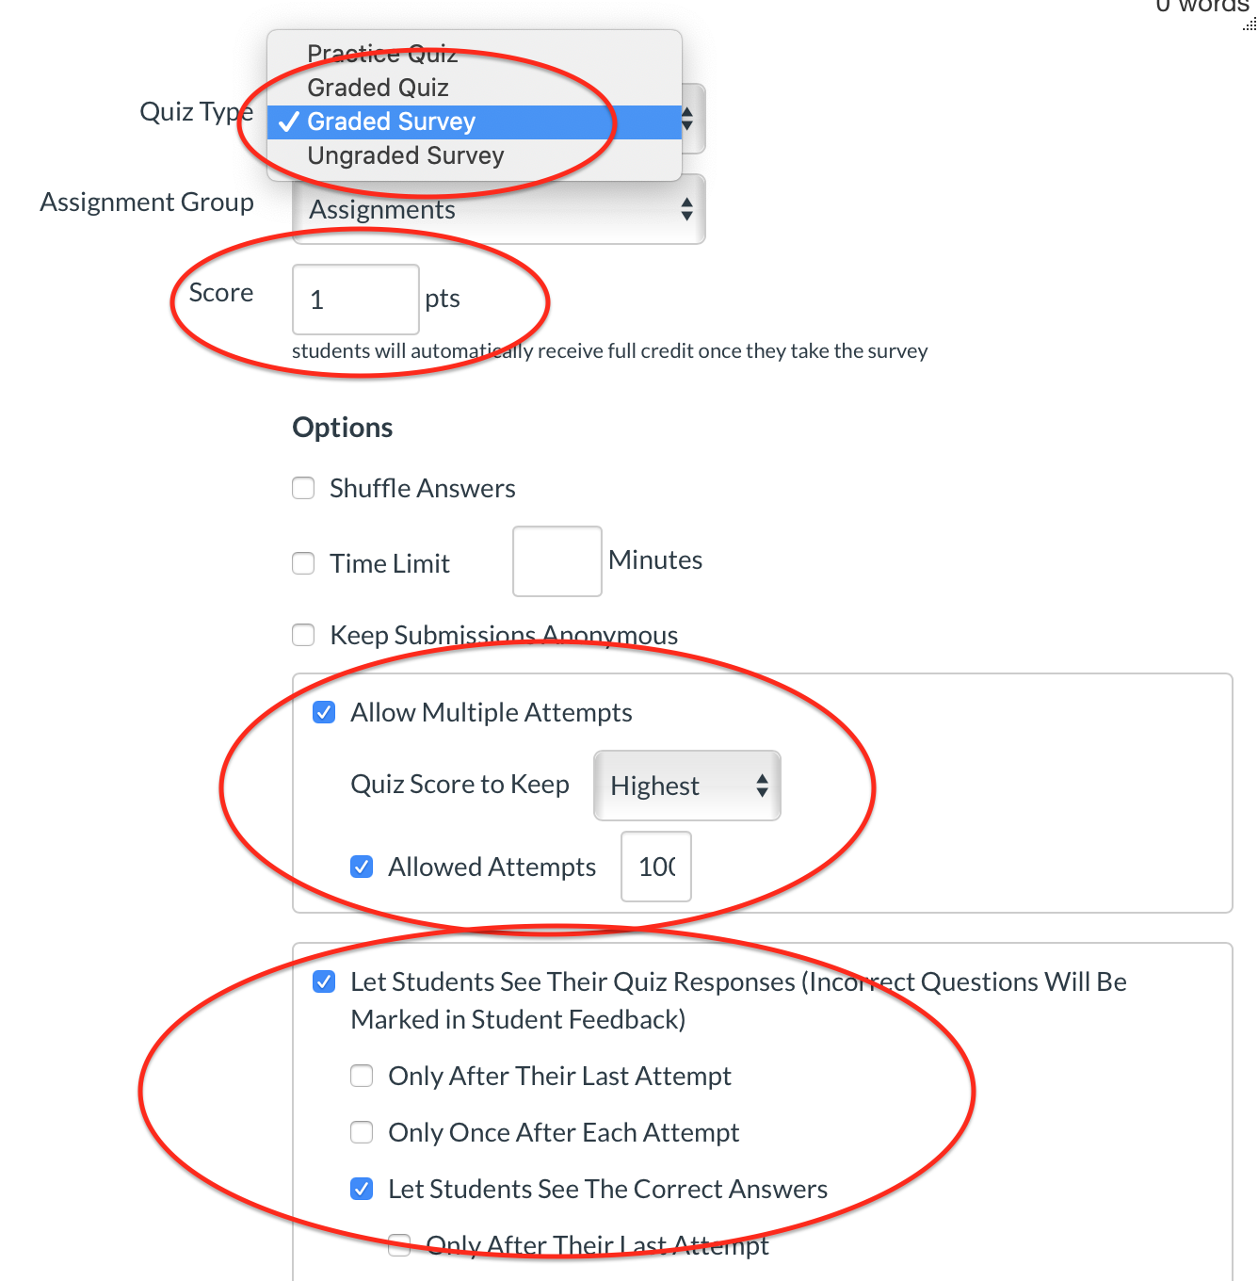

4. In my iClicker grading scheme, I’d assign 1 point. I wouldn’t care about shuffling answers or time limits.

5. Set the dates. Some instructors may want to have only a limited window of time available for each quiz. I, personally, would leave it open for the whole unit because students will benefit from practice and may not be available to take the quiz in a limited time window (life, health, etc.).
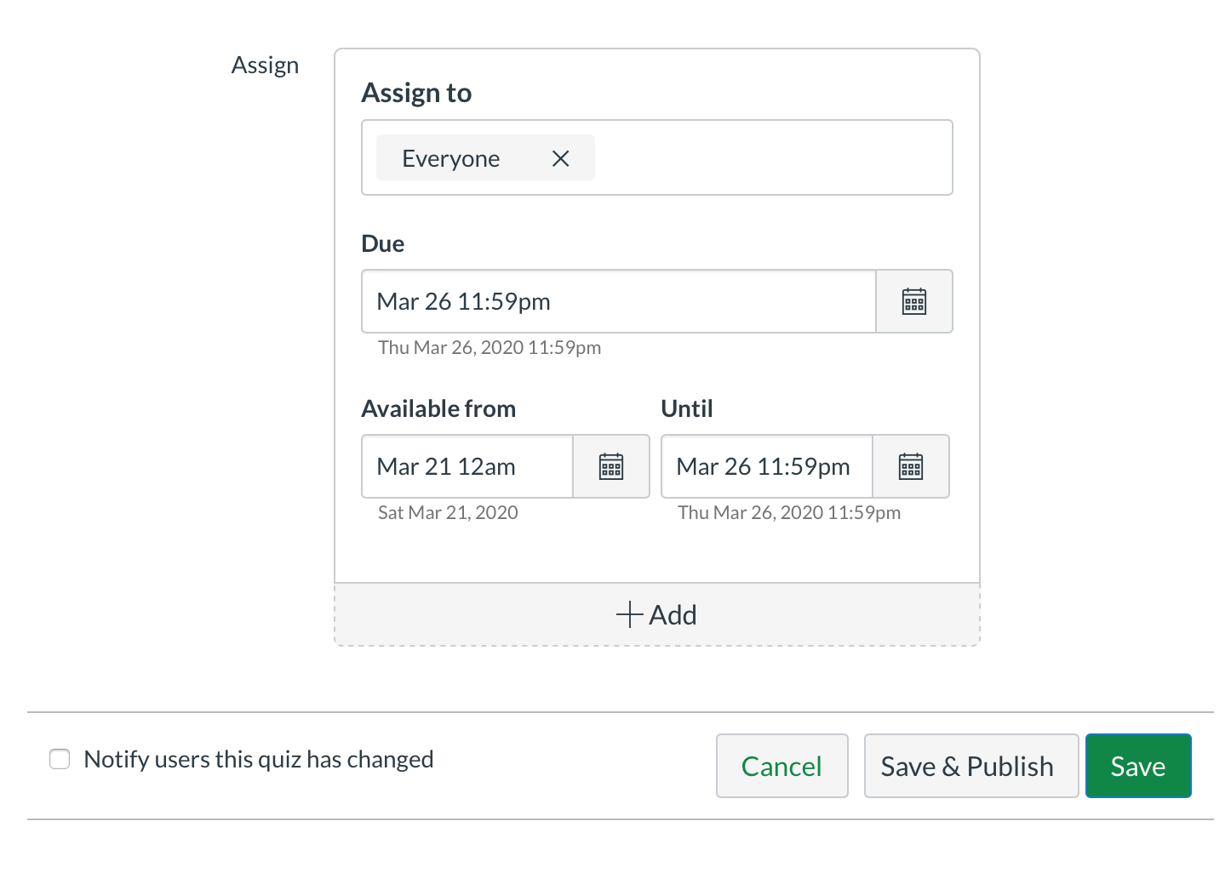

6. Go back to the top of the page and click “Questions”
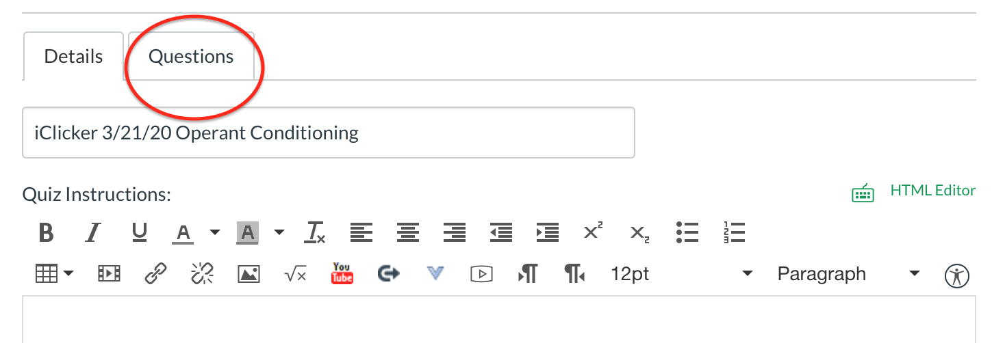

7. Enter in the questions using the “+ New Question” button.
- I would do all iClicker questions for a lecture in 1 quiz rather than 1 quiz per question.
- The default is to make each question worth 1 point.
  - This is arbitrary, since earlier you set the quiz to be worth 1 point.
- When you’re done, you can hit Save (which saves the quiz until you’re ready to publish) or Save and Publish, which makes it available to students starting on the date you set in Step 5.
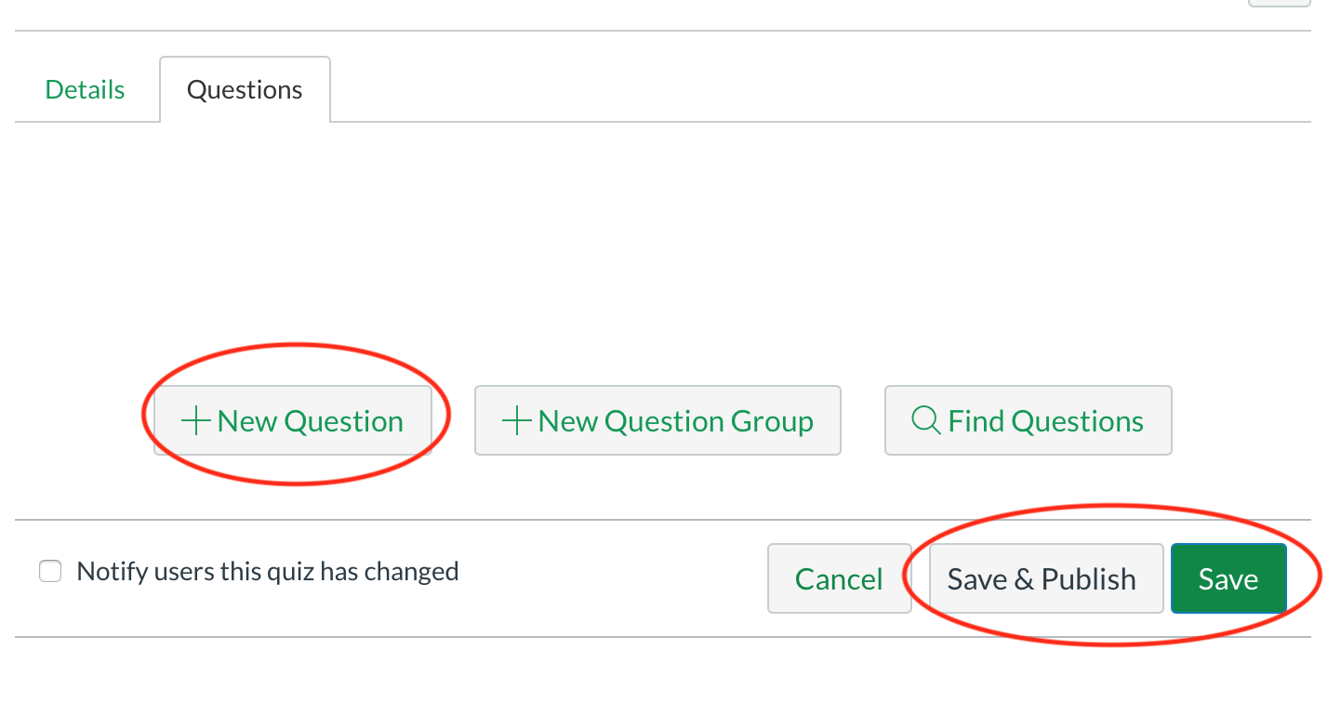

8. Now, go to your Canvas gradebook. You’ll see the iClicker quiz is worth 1 point. Let’s change the grade posting policy so students cannot see the iClicker grade (this makes it so the grade isn’t getting factored into the overall course grade students see). Choose options (3 dots) and “Grade Posting Policy”.
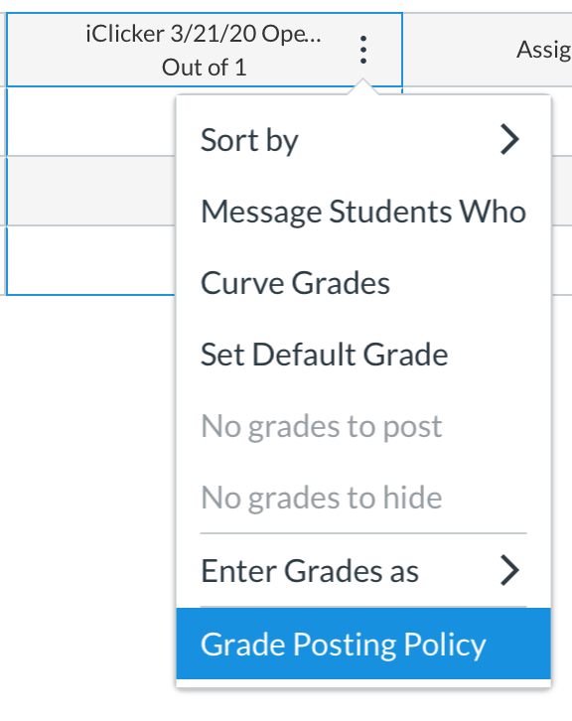

9. Choose “Manually” and hit “Save”.

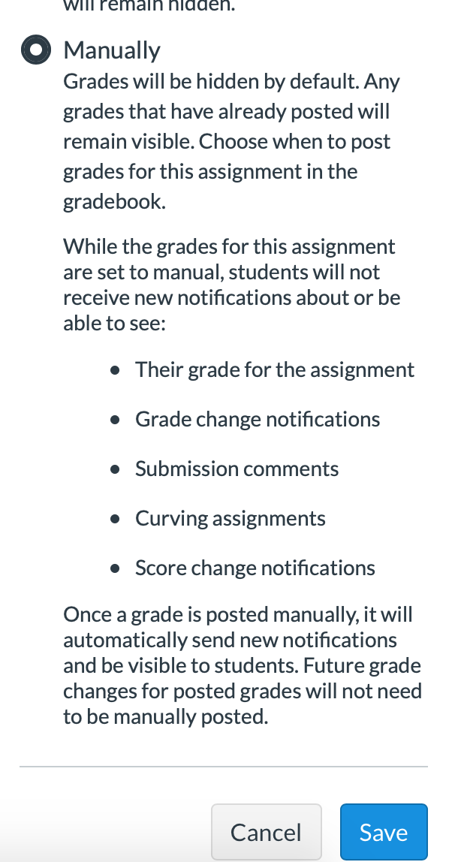

Other Assignments (Mini Writings, Writing Assignments, etc)

We have to provide the points that have been in your syllabus all semester. Please also maintain assignments and policies as best as we can. For example, if your syllabus says:
- Students’ grades are based on a total of 800 points keep 800 points
- The class has 10 mini writings keep 10 mini writings
- If you drop the lowest exam grade drop the lowest exam grade

We can change how we deliver the assignments.

- Please do as much through Canvas as possible
  - Protect your email inbox!
  - We can do almost everything on Canvas except upload videos

- Consider assigning Mini Writings as assignments students submit or as discussion board posts on Canvas.
  - Do not have students email these to you!

- Keep using LaunchPad as you have been all semester

Due Dates, Announcements, and Teaching Teams

- As we discussed, please change all assignment due dates to Sundays 11:59 pm
  - New due dates should be after the original due dates. So, if Writing Assignment 3 was due Wednesday, April 1st, please change it to Sunday, April 5th.
  - This will help students who may need additional time due to health or significant life events.
  - This will help you to only have to post one reminder announcement with the list of things due each week.
  - We may need to have flexibility with due dates (especially early on in the transition) within reason.
  - We need to continue to provide SDC accommodations for assignments.

- Please post weekly announcements. For the first few weeks of this transition, include:
  - How to contact you for office hours
  - Where to find this week’s lecture videos on Canvas
  - When livestreaming sessions are scheduled, where livestream recordings can be found later, and that it may take a couple of days for recordings to be available
  - Assignments due for the week, including exams if it’s an exam week
    - I think it’s easiest if everything for the week (video links, assignments, exams, etc) is in one place on Canvas. That way, a student knows it is Week __, dates __ to __, and here is everything I need to do for the week in one folder.

- Teaching Teams
  - Please continue to have calibration meetings with WGTAs. These can be conducted over Teams, Zoom, etc.
  - Please maintain grading deadlines that accommodate the changes in assignment due dates.
  - Please maintain frequent contact with team members to keep them engaged, but not so frequent they get overwhelmed with emails.
  - Remember that GTAs are assigned 10 hours per week. Be thoughtful about what tasks you give them.
  - I strongly advise against giving undergraduate TAs access to your gradebooks.

